ANNEXURE IV

PARENT CONSENT FORM

LETTER OF UNDERTAKING

I, Edward Raja .K ( (Parent name) hereby undertake in respect of my son/daughter Dickson E (Student Name) Reg. No. URK23AI1072 of the Department of
Data Science and Cyber Security of Karunya Institute of Technology and Sciences that he will be of good behavior and obedient to the staff of the Institute during the Extra-curricular Industrial visits.

He/She will also abide the rules and regulations of the institution and will not participate in any activity that will breach the scope of the programme.

I am fully aware and approve the participation of my son/daughter in the programme between 4:00 am and 11:30 pm at (29.02.2024).

I will not hold the Karunya Institute of Technology and Sciences responsible in any way in any eventuality namely accident / injury / death or whatever mishap.

I solemnly affirm my acceptance.

Name of the Parent : Edward Raja .K

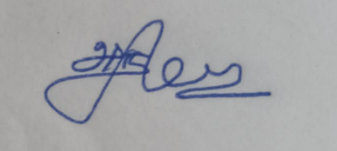

Signature of Parent:

Address:
1/967-A,Anna Nagar,
Vaiyampatty(post) , Manaparai(Tk) ,
Trichy(Dt) – 621315.

Date: 23.02.2024

